APPLICATION FOR MUTUAL RECOGNITION

Through the Mutual Recognition arrangement between the Korea Institute of Design Promotion (KIDP) and Good Design Australia Pty Ltd., products recognized by GOOD DESIGN KOREA may apply for recognition under the Australian Good Design Awards.

KIDP will verify the applicant’s GOOD DESIGN KOREA selection information and forward the required product and award details to Good Design Australia.

Following confirmation of eligibility, Good Design Australia will provide separate instructions regarding the applicable recognition fee and payment process.

The relevant Australian Good Design Awards trademark and recognition benefits will become available once the required payment and recognition procedures have been completed with Good Design Australia.

AWARD TIER EQUIVALENCE
GOOD DESIGN KOREA |  | AUSTRALIAN GOOD DESIGN AWARDS
Winner | → | Good Design Award Winner (Green Tick)
Bronze Prize  Silver Prize | → | Good Design Award Gold Winner (Gold Tick)
Gold Prize | → | Good Design Award Best in Class (White Tick)
Grand Prize | → | Good Design Award of the Year (Black Tick)

APPLICATION INFORMATION (REQUIRED)
Product Name | Company Name | Selected Year  (of GOOD DESIGN KOREA) | Registration No. | Award Level  (Winner ~ Grand Prize)
* Please provide all application information in English.

CONFIRMATION
I confirm that the information provided above is accurate and agree that the necessary product and award information may be shared with Good Design Australia for the purpose of processing this
Mutual Recognition application.

Date :

Name :

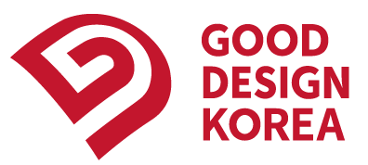 | 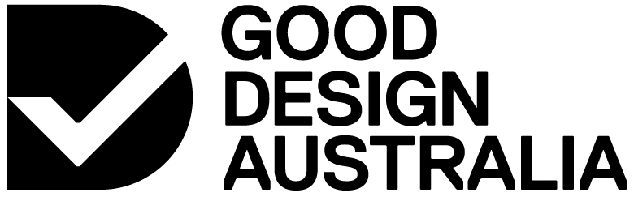
Signature :

